Exercise 1 – Latch
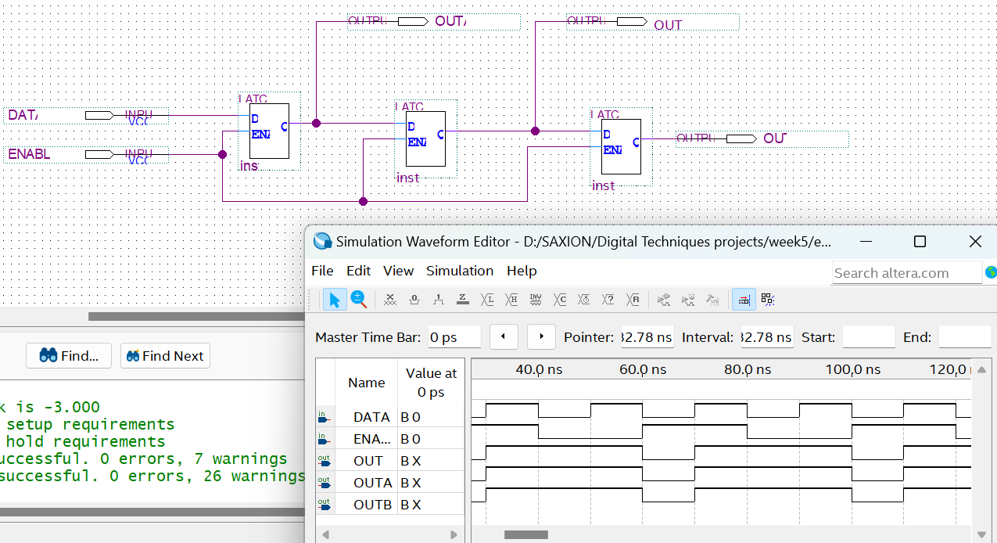
- A D-latch works like a memory unit by capturing and holding the value from its DATA input when the control signal (ENABLE) is on. Once it captures that value, it holds onto it even if the control signal turns off. This makes it handy for tasks like storing data and timing operations.
- When ENABLE is activated, D can control the current which affects the outputs. When ENABLE turns off, D can do nothing and the outputs retain the same value as before the ENABLE turned off.

Exercise 2 – D-Flip Flop
- A D flip-flop functions as a memory cell that stores a single bit of data. It checks the value at its input (D) whenever the clock signal changes and retains that value at its output (Q) until the next clock signal. This allows it to keep the information even if the input changes after it’s been captured.

- The D flip-flop and the latch are both used to store data, but they work in different ways. A D flip-flop updates its output only at certain moments, specifically when the clock signal changes. This makes it reliable for applications where timing is important. On the other hand, a latch continuously follows its input as long as a control signal is active, which means it can change at any time. While D flip-flops are often found in things like registers and counters that rely on precise timing, latches are typically used for temporary storage when a clock isn’t needed.
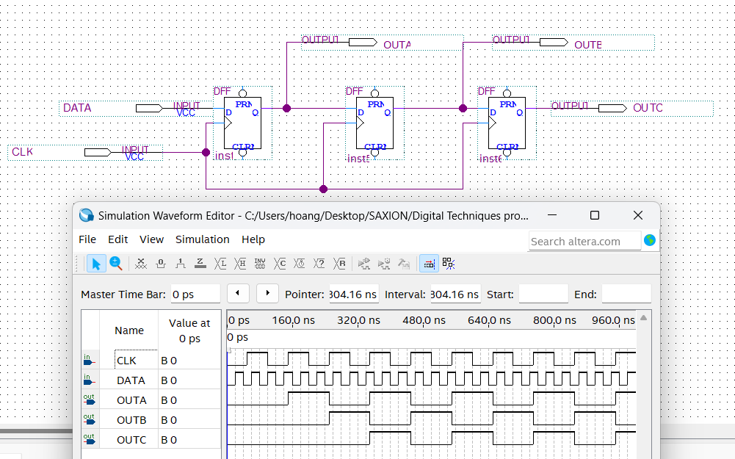
Exercise 3 – Frequency Divider
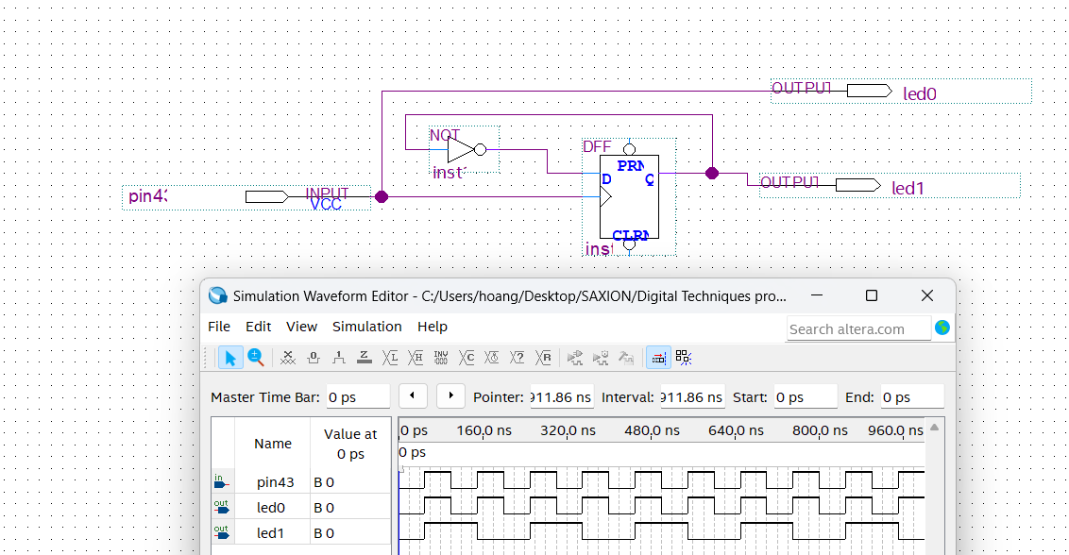
When rotating the potentiometer, it adjust the frequency of the 2 outputs

Exercise 4 – Two-bit counter
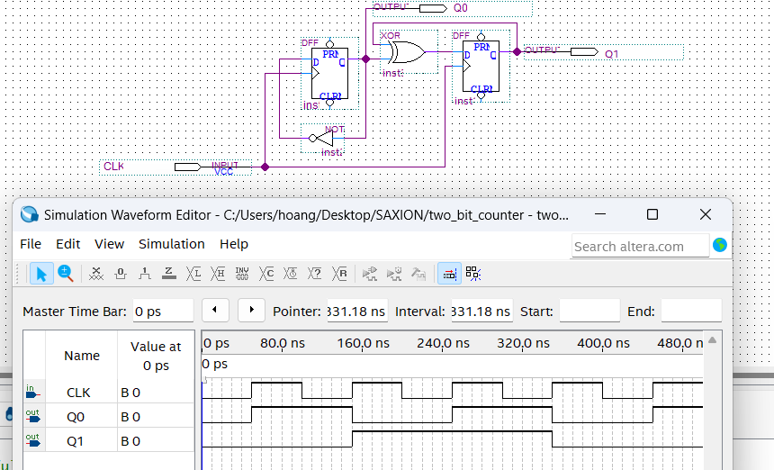
A two-bit counter is a simple digital device that counts from 0 to 3. It uses two bits, which can show four different values: 00 (0), 01 (1), 10 (2), and 11 (3). When it receives a clock signal, it increases its count by one each time, looping back to 00 after reaching 11. This kind of counter is often used in digital circuits for basic counting tasks, like tracking steps in a process or dividing frequencies.

